Configuration.

In order to use the program you have to open the file “config.cmd” with a text editor, and adjust some settings.
The file is located in the directory “videnc\bin”.
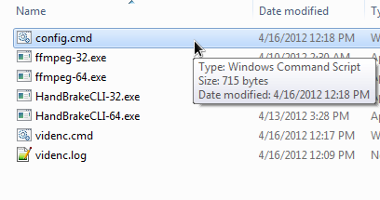

Note: for simple usage of the procedure, you only have to adjust two settings: OSARCH and DIRWORK.

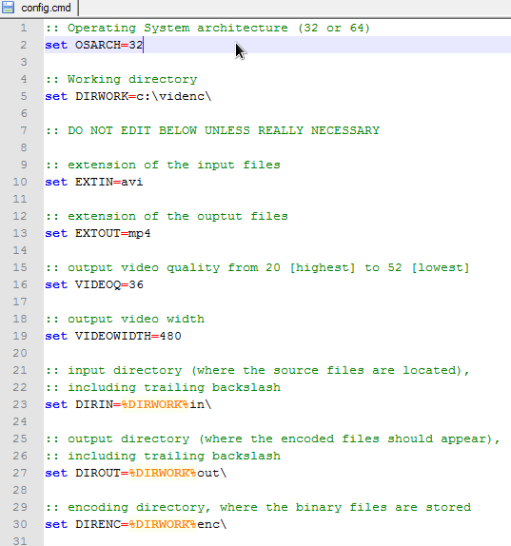

Configuration settings:

OSARCH
- Operating System architecture (32bit or 64bit);
- Valid settings: 32, 64;

DIRWORK
- Working directory, where you copied/extracted the archive;
- Trailing backslash is mandatory;

EXTIN
- Video extension for input files;
- For example, if you specify “avi”, only avi files will be processed;

EXTOUT
- Video extension to use for the main output file;
- Valid settings: mp4, m4v;

VIDEOQ
- Output video quality;
- Lowest quality setting: 52;
- Highest quality setting: 20;
- Valid settings: any number between 20 and 52;

VIDEOWIDTH
- Output video width;
- Recommended to use the default of 480;

DIRIN
- Input directory;
- Only modify for advanced usage!

DIROUT
- Output directory;
- Only modify for advanced usage!

DIRENC
- Encoding directory;
- Only modify for advanced usage!

